Beaconsfield Cycle Path Action Group

- 300 residents have completed our survey
- 96% think a cycle network in Beaconsfield is a good idea
- So much so that 31% have offered to be involved
- The children want to cycle to school
Beaconsfield Schools 2011-2012 “Hands Up” Survey Data
Mode of transport | Cycle | Walk | Bus/train/taxi | Scooter | Car (not car share) | Car share
How do you get to school? | 5% | 27% | 23% | 4% | 34% | 6%
How would you like to get to school? | 27% | 18% | 19% | 7% | 19% | 10%

- 52% of Beaconsfield School pupils (75% of primary school pupils) live within cycling distance of their school yet only 36% currently walk, cycle or scoot.

- If we can respond to our children’s desires and reduce car journeys to 19% there would be 500 fewer cars making two round trips each day – 2000 fewer car journeys.

- Traffic conditions will improve for drivers, cyclists and pedestrians when that is achieved.

- Our proposals are well known. Our survey has been circulated to all schools at least twice; posters are up around town, flyers distributed at the station. We were one of Beaconsfield Waitrose's community schemes in October.

- We are supported by the Town Council, Leader of the District Council, County Council, Sustrans, Cabinet Minister, our MP Dominic Grieve QC, all the Beaconsfield schools both primary and secondary, and many members of the public . We urge the Forum also to support us tonight.

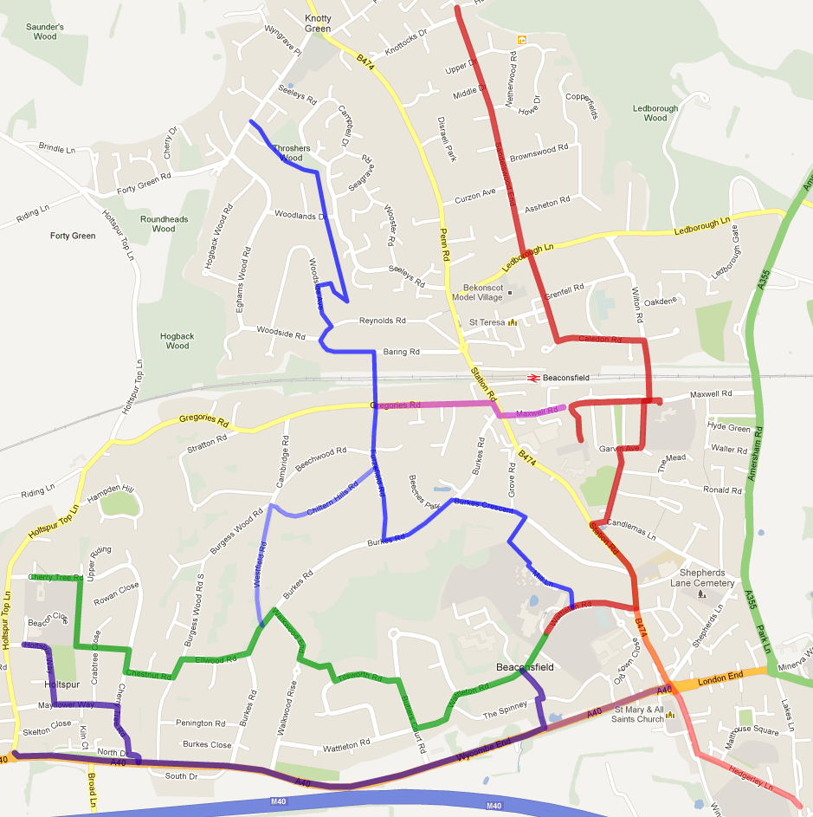
The route proposals
Red Route
Links Knotty Green and Beaconsfield Old Town
Links 5 schools

Blue Route
Links Forty Green and Beaconsfield Old Town
Green Route
Links Holtspur and Beaconsfield Old Town
Links into Blue, red, Purple routes
Purple Route
Links Holtspur Top and Beaconsfield Old Town, along the A40

